Age of Exploration Map
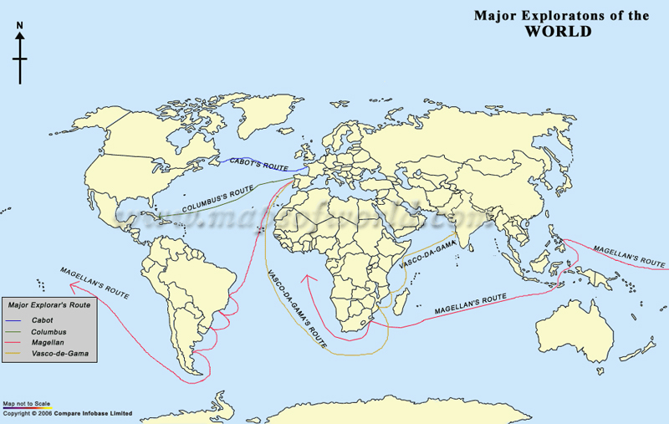
Step 1: Label the 7 continents and the following oceans: Atlantic, Pacific, Indian.
Step 2: Select 4 Different Colored Pencils. Trade each exploration route in a different colored pencil. Then indicate which color was used for each route by drawing a line on the map key.
Step 3: Answer the questions on the following page.
Step 4: Identify trends among the explorers in the chart below.
Which Continent did these explorers come from?
Where were these explorers trying to go?
What did these explorers want to get?
Around what Time period were these men exploring?

Read the passages and answer the questions below.
- In the 15th and 16th centuries, the Europeans wanted to find sea routes to the East. Columbus wanted to find a new route to the Far East, to India, China, Japan and the Spice Islands. If he could reach these lands, he would be able to bring back rich cargoes of silks and spices. Columbus knew that the world was round and realized that by sailing west, instead of east around the coast of Africa, as other explorers at the time were doing, he would still reach the East and the rich Spice Islands. After sailing across the Atlantic Ocean for 10 weeks, land was sighted by a sailor called Rodrigo Bernajo. Columbus himself took the credit for this sighting. He believed he had reached Asia when he arrived in Cuba. The year was 1492.
- Why did Columbus want to develop a new trade route?

- In which direction did he sail to get to the Far East?

- Where did Columbus believe he had arrive and where did he actually end his voyage.

- Magellan devised a plan for circumnavigating the globe, and King Charles V of Spain gave it his blessing. On September 20, 1519, he set out with a fleet of five ships, beautifully named but hardly adequate to sail the distances he proposed. The fleet sailed first to Brazil and then down the coast of South America to Patagonia. There, an attempted mutiny took place, and one of the ships was wrecked. Despite the setback, the crew continued on with the four remaining vessels. In March 1521, the fleet anchored in Guam. It is a lesser-known fact that Magellan became involved in a local war in the Philippines, where he was killed in battle on April 27, 1521.
- Based on Magellan’s route on the map, what do you think the word circumnavigate means?

- Why was Magellan’s trip was considered unique or special?

- In early May of 1497, Cabot left Bristol, England with a crew of 18 men. Cabot and his crew sailed west and north under Cabot's belief that the route to Asia would be shorter from northern Europe than Columbus's voyage along the trade winds. On June 24, 1497, 50 days into the voyage, Cabot landed on the east coast of North America, tin present day Canada.

- Where did John Cabot’s voyage start and where did it end?

- What was John Cabot hoping to achieve by sailing West and North?

- In 1497, Vasco da Game embarked on a voyage to find an ocean route to India. Vasco da Gama pointed his ships south, taking advantage of the prevailing winds along the coast of Africa. His choice of direction was also a bit of a rebuke to Christopher Columbus, who had believed he'd found a route to India by sailing east. Following several months of sailing, he rounded the Cape of Good Hope, which is the southernmost point in Africa and began making his way up the eastern coast of Africa, toward the uncharted waters of the Indian Ocean. His choice of direction was also a bit of a rebuke to Christopher Columbus, who had believed he'd found a route to India by sailing West.
- Around which continent did Vasco de Gama sail to reach Asia?

- What was Vasco de Gama’s opinion of Columbus?

