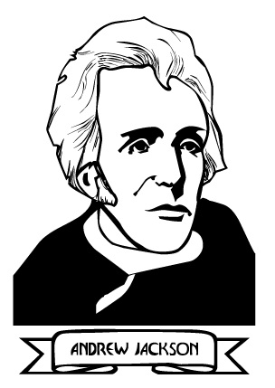
The Good | The Bad | The EVIL

