Amendment Number  Fill in the blanks to the Amendment Chart below!! | Defintion | Picture
 | Congressional pay raises won’t take effect until the next election for representatives
13th |  | 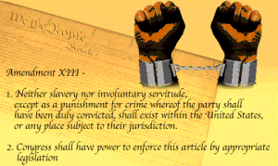
24th
 | The right to a lawyer
3rd
9th | The rights given to the people
 | Equal citizenship for everyone
10th |  | 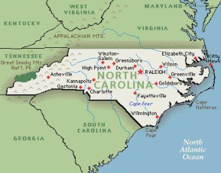
5th | Due Process, Eminent Domain, Double Jeopardy, Grand Jury, Self-Incrimination
11th | Suits against states
12th | Process for electing the President and Vice President
16th
 | People directly elect the Senators
 |  | 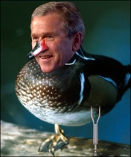
4th
 | The right to a jury in CIVIL cases
15th | African American males given the right to vote
 |  | 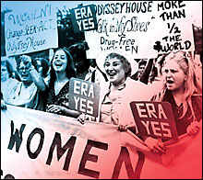
22nd | President can serve a maximum of 2 terms, or 10 years
 |  | 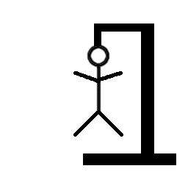
 | Right to a trial by jury in civil cases
23rd
25th

