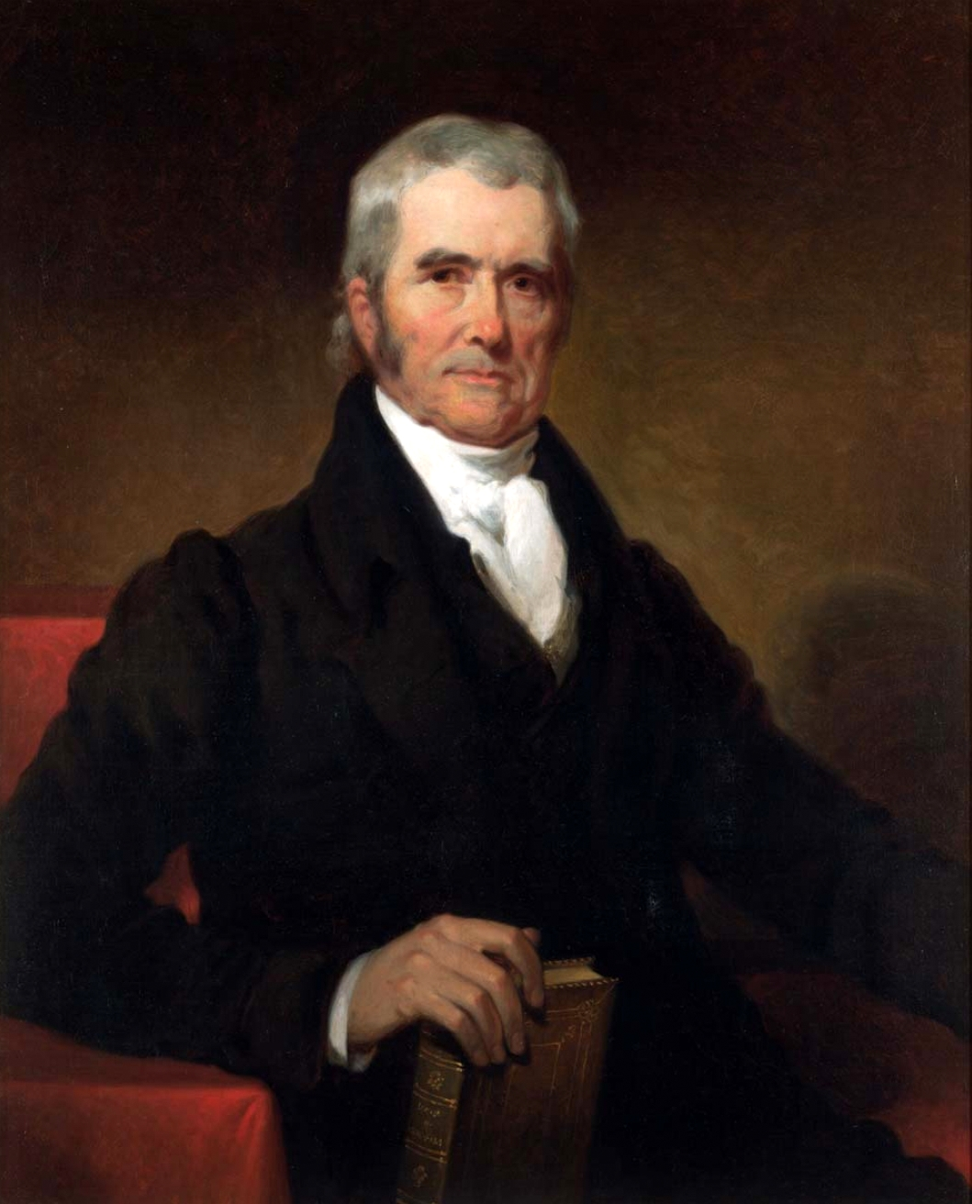

After being assigned a Supreme Court Case, your group of 3 will complete two tasks:

1. A turned in ½ - 1 page answering the following questions about your case:
- What was the issue? What amendment was involved? (2 sentences)
- What was the background of the case? (4-5 sentences)
- What did the Supreme Court rule? (1-2 sentences)
- What impact did the decision leave? (1-2 sentences)
- What is your opinion? Do you agree or disagree? Why? (3-4 sentences)

2. Present a short video using the following guidelines:
- 30 seconds-1 minute
- Tells the story of your case
- Uses at least 1 prop (self-made or found in the classroom)

Cases:
- Fletcher v. Peck
- McCulloch v. Maryland
- Gibbons v. Ogden
- Cohens v. Virginia
- Dartmouth College v. Woodward
- Worcester v. Georgia

